**DAILY ONLINE ACTIVITIES SUMMARY**

|  |  |  |  |  |  |  |  |  |
| --- | --- | --- | --- | --- | --- | --- | --- | --- |
| **Date:** | **03-7-2020** | | | | | **Name:** | **poojashree** | |
| **Sem & Sec** | **8th sem A sec** | | | | | **USN:** | **4al16cs065** | |
| **Online Test Summary** | | | | | | | | |
| **Subject** | | **sms** | | | | | | |
| **Max. Marks** | |  | | **Score** | | |  | |
| **Certification Course Summary** | | | | | | | | |
| **Course** | **Introduction to cyber security** | | | | | | | |
| **Certificate Provider** | | | **Great learning academy** | | **Duration** | | | **5.5hr** |
| **Coding Challenges** | | | | | | | | |
| **Problem Statement:**  **1. print python program to check balanced paranthesis using stack** | | | | | | | | |
| **Status:completed** | | | | | | | | |
| **Uploaded the report in Github** | | | | | **yes** | | | |
| **If yes Repository name** | | | | | **Poojashree** | | | |
| **Uploaded the report in slack** | | | | | **yes** | | | |

**Online test**

**----------no marks -----------**

**Certification course**

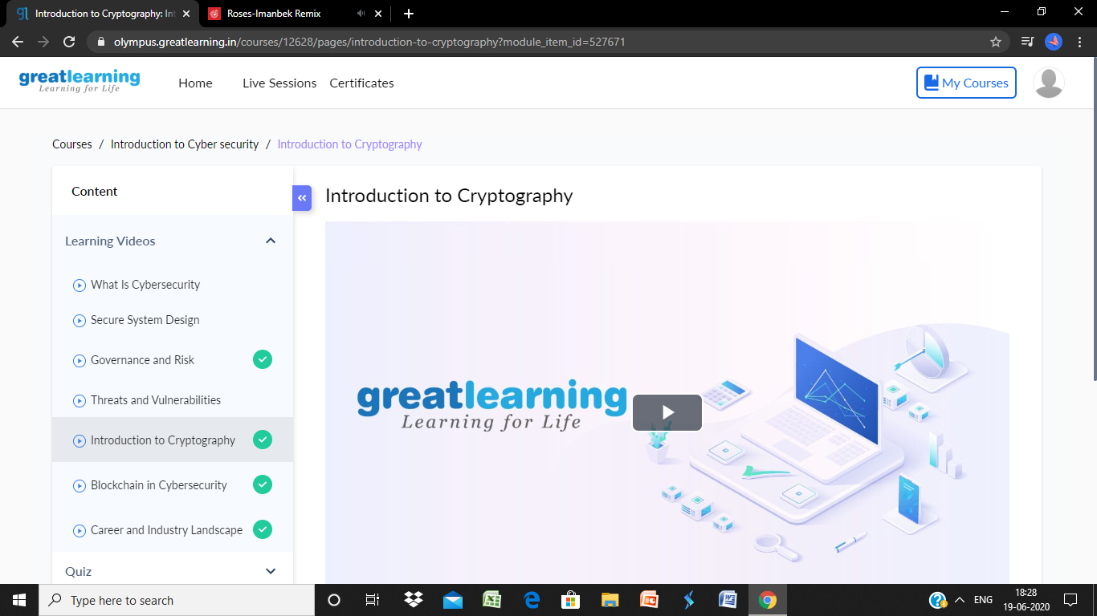

**Coding**

**Program 1**

**class Stack:**

**def __init__(self):**

**self.items = []**

**def is_empty(self):**

**return self.items == []**

**def push(self, data):**

**self.items.append(data)**

**def pop(self):**

**return self.items.pop()**

**s = Stack()**

**exp = input(‘Please enter the expression: ‘)**

**for c in exp:**

**if c == ‘(‘:**

**s.push(1)**

**elif c == ‘)’:**

**if s.is_empty():**

**is_balanced = False**

**break**

**s.pop()**

**else:**

**if s.is_empty():**

**is_balanced = True**

**else:**

**is_balanced = False**

**if is_balanced:**

**print(‘Balanced’)**

**else:**

**print(‘Unbalanced’)**